The Olive Grove Restaurant Website

1. Introduction
The Olive Grove Restaurant Website is a restaurant website developed using HTML5 and CSS3. It provides information about the restaurant's menu, chefs, ambience, customer reviews, opening hours, location, and table reservation facility.
The main objective of this website is to create an attractive online presence for a restaurant and help customers explore its food menu and reserve tables easily.
Website name: The Olive Grove Restaurant
Tagline: Good Food · Great Company · Lasting Memories
Technologies used:
- HTML5: Used to create the structure and content of the website.
- CSS3: Used to style the website and create an elegant design.
- External images: Used to display food items, chefs, and restaurant interiors.

2. Explanation of the Code
The code contains two main parts: HTML and CSS.
A. HTML code explanation
HTML defines the structure and content of the website.
HTML tag | Explanation
<!DOCTYPE html> | Declares the document as HTML5.
<html lang="en"> | Defines the HTML document and its language.
<head> | Contains page settings and the website title.
<meta> | Provides character encoding and responsive viewport settings.
<title> | Sets the browser tab title.
<style> | Contains the CSS styling rules.
<body> | Contains the visible website content.
<header> | Displays the restaurant logo and navigation bar.
<nav> | Provides links to the website sections.
<section> | Divides the website into different content areas.
<div> | Groups related elements together.
<h1>, <h2>, <h3> | Display headings of different levels.
<p> | Displays text and descriptions.
<a> | Creates clickable navigation links and buttons.
<img> | Displays food, chef, and restaurant images.
<span> | Highlights menu prices within food descriptions.
<form> | Creates the table reservation form.
<input> | Accepts customer name, email, phone, date, and time.
<select> and <option> | Allow customers to select the number of guests.
<button> | Provides the Book Now submission control.
<footer> | Displays the restaurant name and copyright information.
B. CSS code explanation
CSS controls the appearance, layout, and responsiveness of the website.
- Universal selector (*): Removes default margins and padding and applies box-sizing: border-box.
- Body styling: Sets the Georgia font, cream background, dark text, and line spacing.
- Header styling: Creates a dark navigation bar with golden text.
- Hero section: Uses a restaurant background image with a dark gradient overlay.
- Grid layout: Arranges menu cards, chefs, reviews, and contact information.
- Flexbox: Aligns the logo and navigation links in the header.
- Hover effects: Changes the color of navigation links and buttons when hovered over.
- Image styling: Uses object-fit: cover to display images neatly within their containers.
- Dark sections: Give the chefs and testimonials sections a dark background with light text.
- Media queries: Change the layout for tablet and mobile screen sizes.

3. Features of the Website
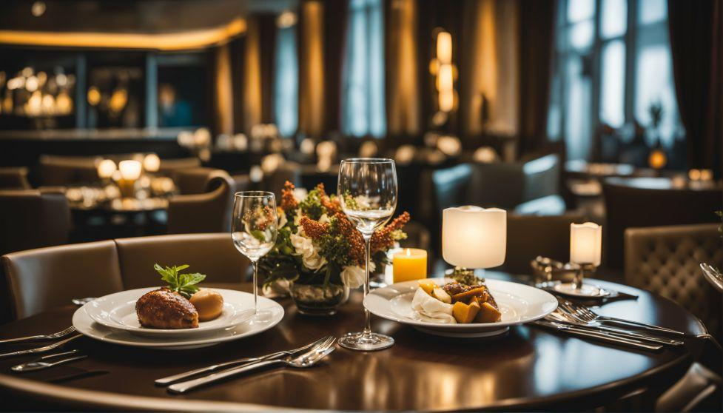
1. Navigation Bar
Displays the restaurant name and links to Home, Menu, Our Chefs, Ambience, Testimonials, and Contact. The Book a Table link takes visitors directly to the reservation form.
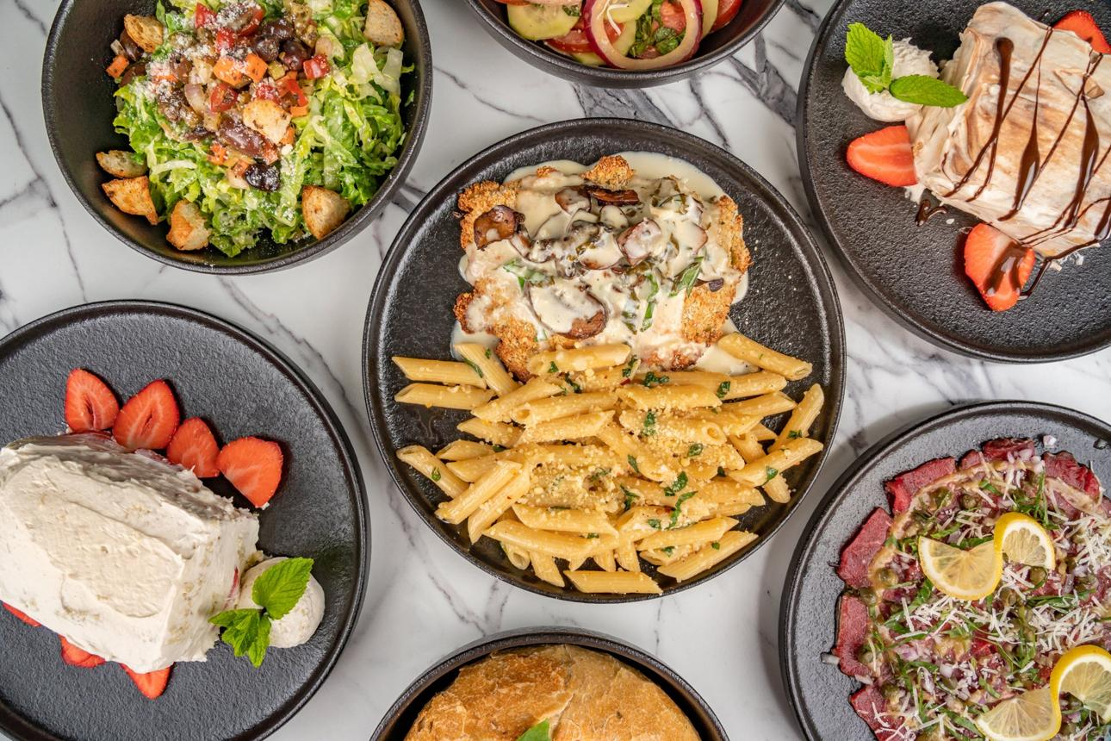
2. Food Menu
Displays four menu categories: Starters, Main Courses, Desserts, and Beverages. Each category contains a food image, dish names, and prices.
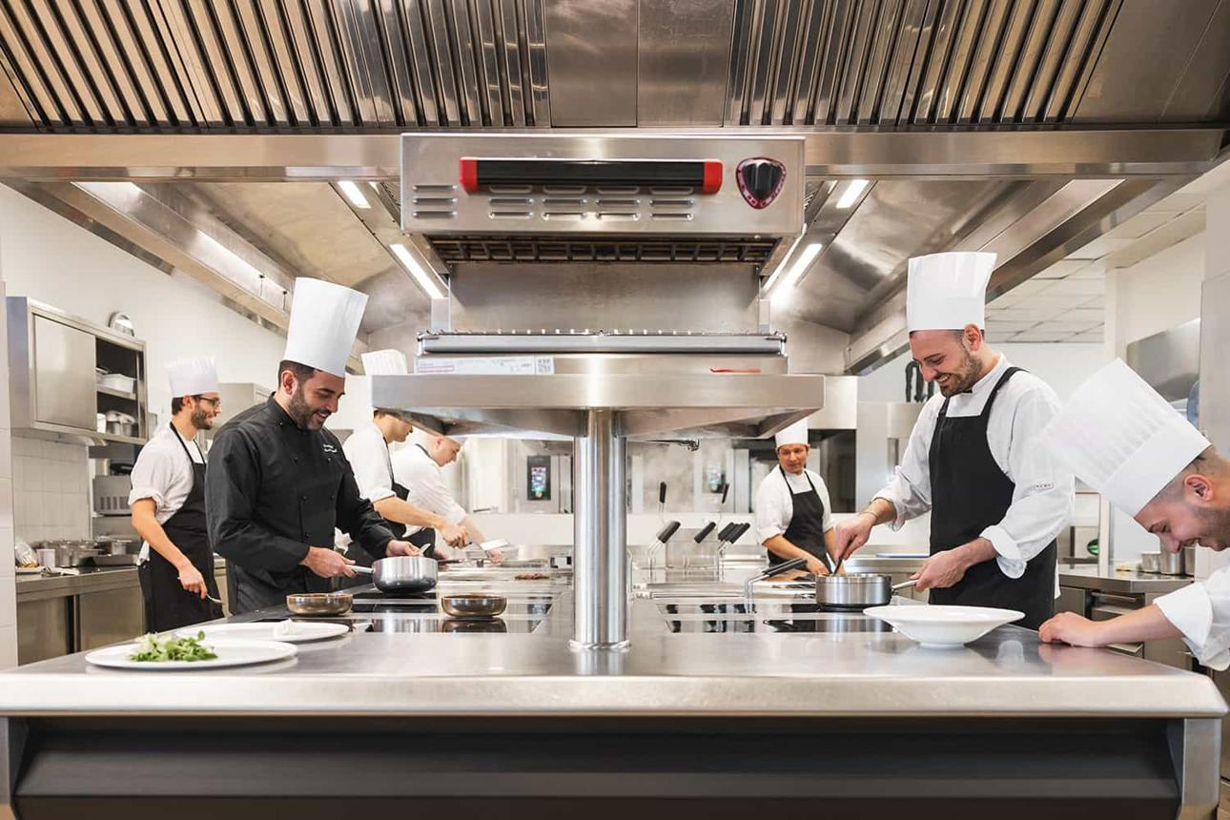
3. Our Chefs
Introduces three chefs with their names, job roles, photographs, and short descriptions.
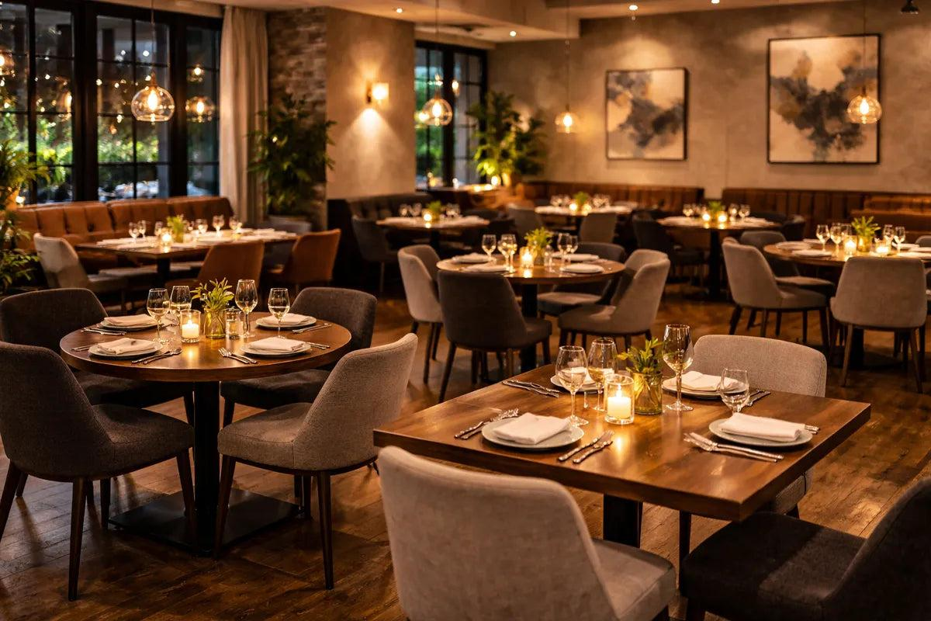
4. Ambience Gallery
Displays three restaurant interior images to give visitors an idea of the dining atmosphere.
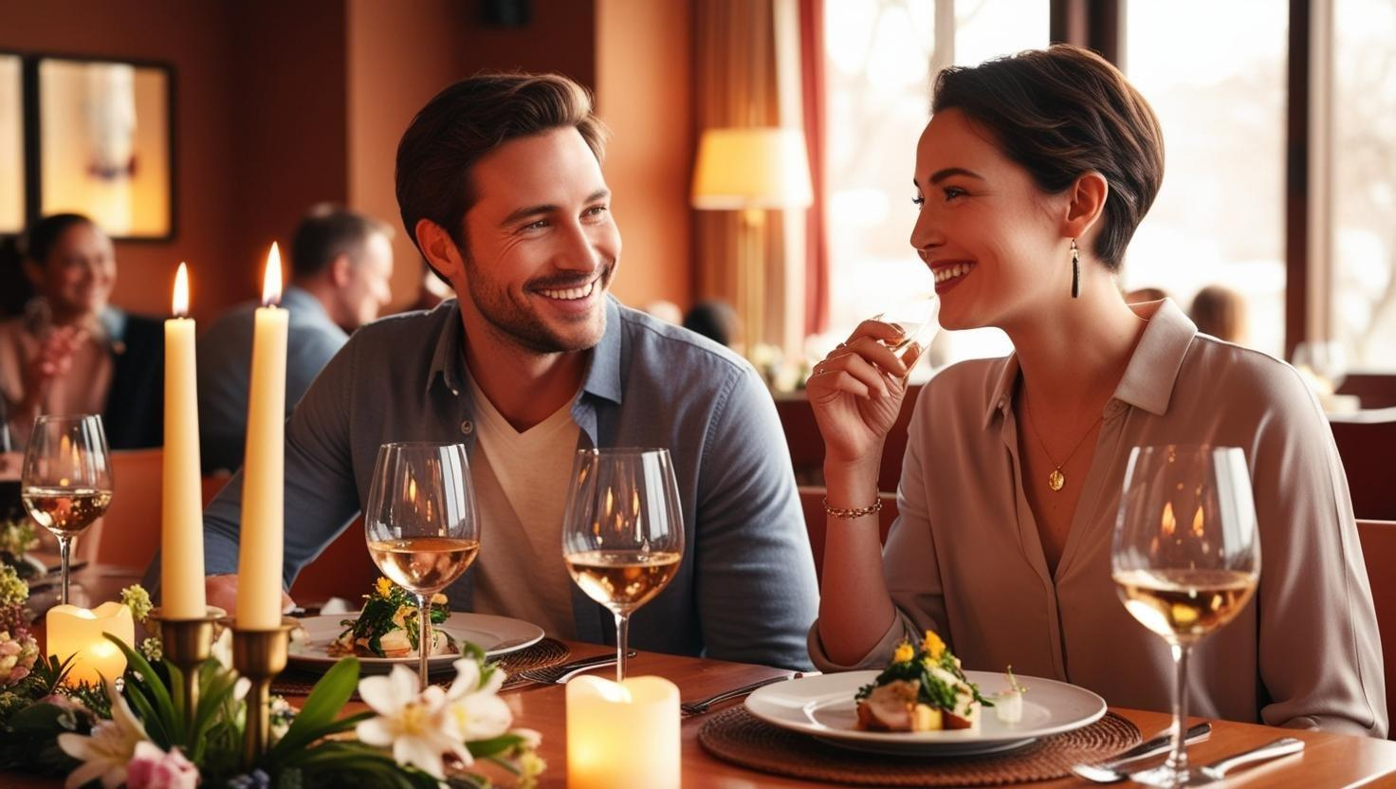
5. Customer Testimonials
Shows three sample customer reviews, customer names, and five-star ratings to demonstrate the review section's design.
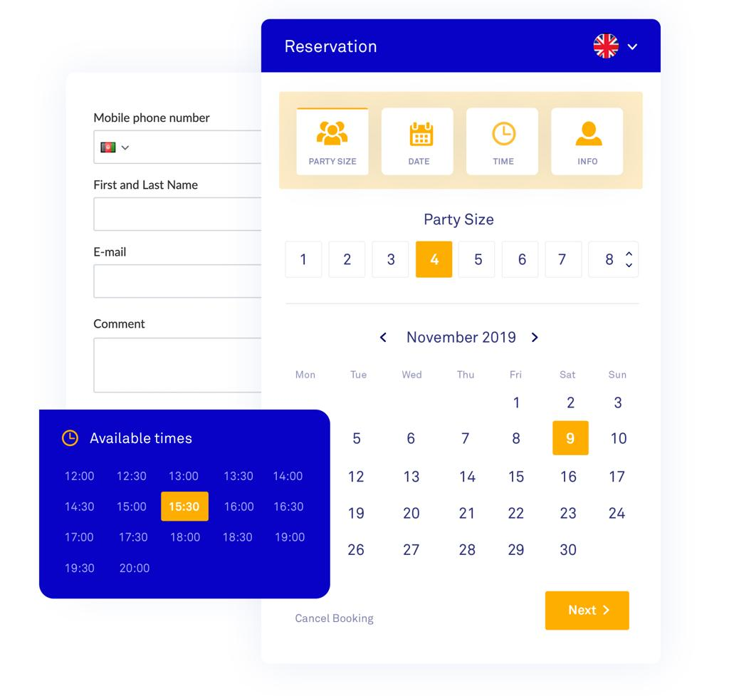
6. Table Reservation Form
Allows customers to enter their name, email, phone number, booking date, time, and number of guests. Required fields use HTML validation.
Other features include smooth scrolling, elegant typography, golden buttons, responsive layouts, restaurant opening hours, location details, contact information, and a copyright footer.

4. Development of the Website
The development process consists of the following steps.
- Step 1: Requirement analysis
Identify the restaurant's needs, such as displaying food menus, introducing chefs, showing customer reviews, and accepting table reservations.
- Step 2: HTML structure
Create the HTML document and divide it into the header, hero section, menu, chefs, ambience gallery, testimonials, contact and reservation section, and footer.
- Step 3: CSS styling
Apply the cream, dark green, black, and golden color scheme, along with fonts, spacing, backgrounds, and borders.
- Step 4: Menu development
Create food cards containing images, item names, and prices using HTML elements and CSS grid layouts.
- Step 5: Chef and gallery sections
Add chef photographs, descriptions, and restaurant interior images to improve the visual presentation.
- Step 6: Reservation form
Add customer input fields, date and time selection, a guest dropdown, and a submission button.
- Step 7: Responsive design
Use CSS media queries at widths of 900px and 600px to adjust the layout for tablets and mobile phones.
- Step 8: Testing
Open the website in a browser and test navigation links, image loading, menu layout, reservation fields, and mobile responsiveness.

5. Website Sections and Their Purpose
Section | Purpose
Home | Introduces the restaurant and its dining experience.
Menu | Displays food categories, dishes, and prices.
Our Chefs | Introduces the restaurant's chefs.
Ambience | Shows the restaurant's interior and atmosphere.
Testimonials | Displays sample customer reviews.
Opening Hours | Provides the restaurant's operating hours.
Location | Displays the address, phone number, and email.
Reservation | Collects information for a table booking.
Footer | Displays the restaurant name, tagline, and copyright.

6. Advantages of the Website
- Provides restaurant information in one place.
- Makes it easy for customers to explore the menu.
- Presents food and restaurant interiors visually.
- Introduces the chefs and their roles.
- Provides a convenient table reservation form.
- Uses an elegant design suitable for a restaurant.
- Adapts the layout to different screen sizes.
- Demonstrates practical HTML and CSS concepts.

7. Limitations and Future Enhancements
The current website is a front-end demonstration. The reservation form does not connect to a server or database, so submitting it does not create a real restaurant booking.
Future enhancements could include:
- JavaScript: Add reservation confirmation messages and additional form validation.
- Python with Flask or Django: Process reservation requests on the server.
- Database integration: Store booking details and customer information.
- Online ordering: Allow customers to order food through the website.
- Payment integration: Support secure online payments.
- Admin dashboard: Manage bookings, menu items, and customer requests.
- Email notifications: Send booking confirmations to customers.

8. Conclusion
The Olive Grove Restaurant website is a restaurant website developed using HTML5 and CSS3. It includes a navigation bar, hero section, food menu, chef profiles, ambience gallery, testimonials, contact details, and a table reservation form.
The project demonstrates essential web development concepts such as HTML elements, CSS Grid, Flexbox, background images, hover effects, form controls, and responsive design. It is suitable for a beginner-level web development project and can be expanded into a complete restaurant management and online reservation system by integrating JavaScript, a backend, and a database.

9.output
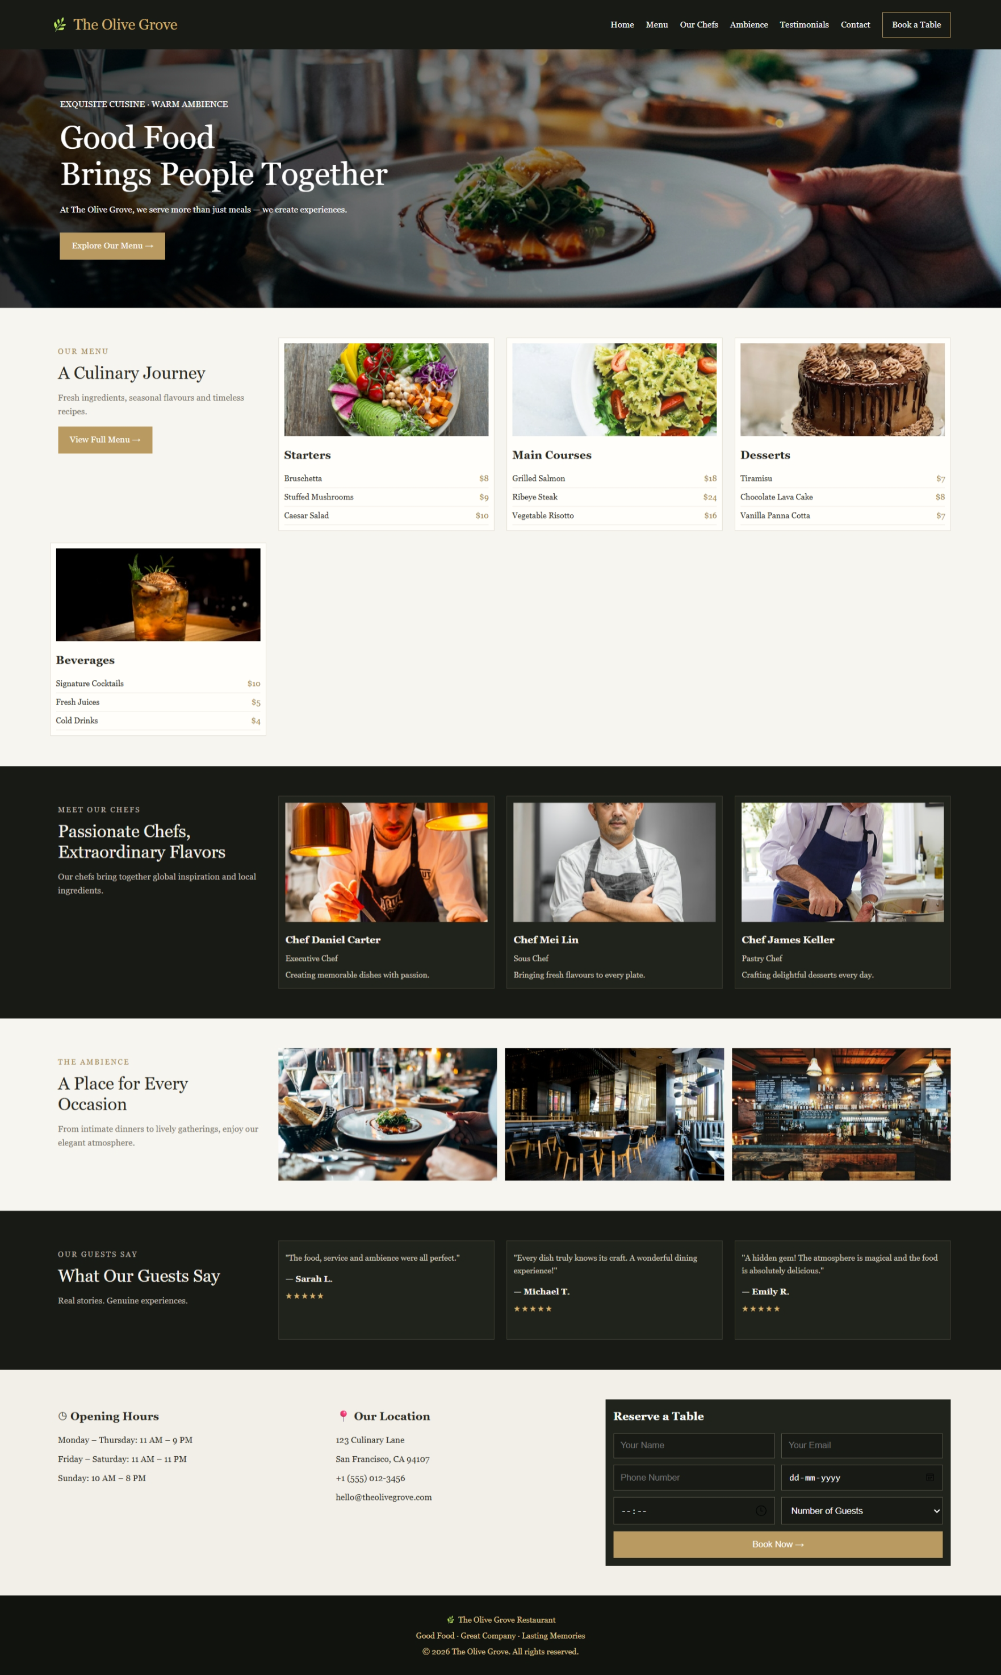

10.code
<!DOCTYPE html>
<html lang="en">
<head>
<meta charset="UTF-8">
<meta name="viewport" content="width=device-width, initial-scale=1.0">
<title>The Olive Grove Restaurant</title>
</head>
<style>

* {
margin: 0;
padding: 0;
box-sizing: border-box;
}

html {
scroll-behavior: smooth;
}

body {
font-family: Georgia, "Times New Roman", serif;
background: #f7f5ef;
color: #292820;
line-height: 1.6;
}

/* Navigation */
header {
background: #171a15;
color: #d5b16b;
padding: 18px 5%;
display: flex;
justify-content: space-between;
align-items: center;
gap: 20px;
}

.logo {
font-size: 22px;
white-space: nowrap;
}

nav {
display: flex;
align-items: center;
gap: 18px;
flex-wrap: wrap;
}

nav a {
color: white;
text-decoration: none;
font-size: 13px;
}

nav a:hover {
color: #d5b16b;
}

nav .book {
border: 1px solid #c5a15d;
padding: 8px 14px;
}

/* Hero */
.hero {
min-height: 390px;
background:
linear-gradient(90deg, rgba(0,0,0,.8), rgba(0,0,0,.12)),
url("https://images.unsplash.com/photo-1414235077428-338989a2e8c0?w=1600")
center/cover no-repeat;
display: flex;
align-items: center;
padding: 50px 6%;
color: white;
}

.hero-text {
max-width: 500px;
}

.hero-text p {
margin-bottom: 12px;
font-size: 13px;
}

h1 {
font-size: clamp(32px, 4vw, 48px);
line-height: 1.15;
margin-bottom: 16px;
font-weight: normal;
}

.btn {
display: inline-block;
background: #b99a60;
color: white;
padding: 10px 18px;
margin-top: 12px;
text-decoration: none;
font-size: 13px;
}

.btn:hover {
background: #8f713c;
}

/* Common sections */
.section {
padding: 45px 5%;
display: grid;
grid-template-columns: repeat(4, minmax(0, 1fr));
gap: 18px;
align-items: start;
}

.intro {
padding: 12px;
}

.intro > p:first-child {
color: #a4874c;
font-size: 11px;
letter-spacing: 2px;
}

h2 {
font-size: 26px;
line-height: 1.2;
font-weight: normal;
margin: 8px 0 12px;
}

.intro p {
font-size: 13px;
color: #777268;
}

/* Food menu */
.food-card {
border: 1px solid #e2ded4;
padding: 8px;
background: #fffefa;
}

.food-card img {
width: 100%;
height: 140px;
object-fit: cover;
}

.food-card h3 {
margin: 8px 0;
font-size: 17px;
}

.food-card p {
font-size: 12px;
border-bottom: 1px solid #eeeae2;
padding: 4px 0;
}

.food-card span {
float: right;
color: #9c7c40;
}

/* Dark sections */
.dark {
background: #171a15;
color: #f8f4eb;
}

.dark .intro p {
color: #c1bdb2;
}

.chef-card,
.review {
border: 1px solid #413e33;
background: #20221c;
padding: 10px;
}

.chef-card img {
width: 100%;
height: 180px;
object-fit: cover;
}

.chef-card h3 {
font-size: 15px;
margin-top: 8px;
}

.chef-card p,
.review p {
font-size: 12px;
color: #d1cabc;
margin-top: 6px;
}

.review {
min-height: 150px;
}

.review h4 {
margin-top: 12px;
font-size: 13px;
}

.stars {
color: #d5b16b !important;
letter-spacing: 2px;
}

/* Ambience gallery */
.gallery {
grid-column: span 3;
display: grid;
grid-template-columns: repeat(3, 1fr);
gap: 12px;
}

.gallery img {
width: 100%;
height: 200px;
object-fit: cover;
}

/* Contact section */
.contact {
grid-template-columns: 1fr 1fr 1.3fr;
background: #f1efe8;
}

.info,
.reservation {
padding: 12px;
}

.info h3,
.reservation h3 {
margin-bottom: 12px;
font-size: 17px;
}

.info p {
font-size: 13px;
margin-bottom: 8px;
}

.reservation {
background: #20221c;
color: white;
}

.reservation form {
display: grid;
grid-template-columns: 1fr 1fr;
gap: 10px;
}

.reservation input,
.reservation select {
width: 100%;
min-width: 0;
padding: 10px;
border: 1px solid #555246;
background: #171a15;
color: white;
}

.reservation button {
grid-column: span 2;
background: #b99a60;
color: white;
border: none;
padding: 12px;
cursor: pointer;
}

.reservation button:hover {
background: #8f713c;
}

/* Footer */
footer {
background: #11130f;
color: #e0c58b;
text-align: center;
padding: 22px;
font-size: 12px;
}

footer p {
margin: 5px;
}

/* Responsive design */
@media (max-width: 900px) {
header {
flex-direction: column;
}

nav {
justify-content: center;
}

.section {
grid-template-columns: repeat(2, minmax(0, 1fr));
}

.gallery {
grid-column: span 1;
grid-template-columns: 1fr;
}

.contact {
grid-template-columns: 1fr 1fr;
}

.reservation {
grid-column: span 2;
}
}

@media (max-width: 600px) {
nav {
gap: 12px;
}

.section,
.contact {
grid-template-columns: 1fr;
padding: 28px 5%;
}

.gallery,
.reservation {
grid-column: span 1;
}

.gallery img {
height: 220px;
}

.food-card img {
height: 200px;
}

.hero {
min-height: 350px;
}

.reservation form {
grid-template-columns: 1fr;
}

.reservation button {
grid-column: span 1;
}
}

</style>
<body>

<!-- Navigation -->
<header>
<div class="logo">🌿 The Olive Grove</div>
<nav>
<a href="#home">Home</a>
<a href="#menu">Menu</a>
<a href="#chefs">Our Chefs</a>
<a href="#ambience">Ambience</a>
<a href="#reviews">Testimonials</a>
<a href="#contact">Contact</a>
<a href="#reserve" class="book">Book a Table</a>
</nav>
</header>

<!-- Hero Section -->
<section class="hero" id="home">
<div class="hero-text">
<p>EXQUISITE CUISINE · WARM AMBIENCE</p>
<h1>Good Food<br>Brings People Together</h1>
<p>At The Olive Grove, we serve more than just meals —
we create experiences.</p>
<a href="#menu" class="btn">Explore Our Menu →</a>
</div>
</section>

<!-- Menu Section -->
<section class="section menu" id="menu">
<div class="intro">
<p>OUR MENU</p>
<h2>A Culinary Journey</h2>
<p>Fresh ingredients, seasonal flavours and timeless recipes.</p>
<a href="#menu" class="btn">View Full Menu →</a>
</div>

<div class="food-card">
<img src="https://images.unsplash.com/photo-1512621776951-a57141f2eefd?w=500" alt="Fresh starter">
<h3>Starters</h3>
<p>Bruschetta <span>$8</span></p>
<p>Stuffed Mushrooms <span>$9</span></p>
<p>Caesar Salad <span>$10</span></p>
</div>

<div class="food-card">
<img src="https://images.unsplash.com/photo-1473093295043-cdd812d0e601?w=500" alt="Pasta">
<h3>Main Courses</h3>
<p>Grilled Salmon <span>$18</span></p>
<p>Ribeye Steak <span>$24</span></p>
<p>Vegetable Risotto <span>$16</span></p>
</div>

<div class="food-card">
<img src="https://images.unsplash.com/photo-1578985545062-69928b1d9587?w=500" alt="Chocolate cake">
<h3>Desserts</h3>
<p>Tiramisu <span>$7</span></p>
<p>Chocolate Lava Cake <span>$8</span></p>
<p>Vanilla Panna Cotta <span>$7</span></p>
</div>

<div class="food-card">
<img src="https://images.unsplash.com/photo-1514362545857-3bc16c4c7d1b?w=500" alt="Beverages">
<h3>Beverages</h3>
<p>Signature Cocktails <span>$10</span></p>
<p>Fresh Juices <span>$5</span></p>
<p>Cold Drinks <span>$4</span></p>
</div>
</section>

<!-- Chefs Section -->
<section class="section dark" id="chefs">
<div class="intro">
<p>MEET OUR CHEFS</p>
<h2>Passionate Chefs,<br>Extraordinary Flavors</h2>
<p>Our chefs bring together global inspiration
and local ingredients.</p>
</div>

<div class="chef-card">
<img src="https://images.unsplash.com/photo-1577219491135-ce391730fb2c?w=500" alt="Chef Daniel">
<h3>Chef Daniel Carter</h3>
<p>Executive Chef</p>
<p>Creating memorable dishes with passion.</p>
</div>

<div class="chef-card">
<img src="https://images.unsplash.com/photo-1583394293214-28ded15ee548?w=500" alt="Chef Mei">
<h3>Chef Mei Lin</h3>
<p>Sous Chef</p>
<p>Bringing fresh flavours to every plate.</p>
</div>

<div class="chef-card">
<img src="https://assets.wsimgs.com/wsimgs/ab/images/i/202632/0008/images/pages/chefs/img_hero_thomas-keller.jpg" alt="Chef James">
<h3>Chef James Keller</h3>
<p>Pastry Chef</p>
<p>Crafting delightful desserts every day.</p>
</div>
</section>

<!-- Ambience Gallery -->
<section class="section" id="ambience">
<div class="intro">
<p>THE AMBIENCE</p>
<h2>A Place for Every Occasion</h2>
<p>From intimate dinners to lively gatherings,
enjoy our elegant atmosphere.</p>
</div>

<div class="gallery">
<img src="https://images.unsplash.com/photo-1414235077428-338989a2e8c0?w=600" alt="Restaurant dining room">
<img src="https://images.unsplash.com/photo-1517248135467-4c7edcad34c4?w=600" alt="Restaurant interior">
<img src="https://images.unsplash.com/photo-1514933651103-005eec06c04b?w=600" alt="Cozy restaurant">
</div>
</section>

<!-- Testimonials -->
<section class="section dark" id="reviews">
<div class="intro">
<p>OUR GUESTS SAY</p>
<h2>What Our Guests Say</h2>
<p>Real stories. Genuine experiences.</p>
</div>

<div class="review">
<p>"The food, service and ambience were all perfect."</p>
<h4>— Sarah L.</h4>
<p class="stars">★★★★★</p>
</div>

<div class="review">
<p>"Every dish truly knows its craft. A wonderful dining experience!"</p>
<h4>— Michael T.</h4>
<p class="stars">★★★★★</p>
</div>

<div class="review">
<p>"A hidden gem! The atmosphere is magical and the food is absolutely delicious."</p>
<h4>— Emily R.</h4>
<p class="stars">★★★★★</p>
</div>
</section>

<!-- Contact and Reservation -->
<section class="section contact" id="contact">
<div class="info">
<h3>◷ Opening Hours</h3>
<p>Monday – Thursday: 11 AM – 9 PM</p>
<p>Friday – Saturday: 11 AM – 11 PM</p>
<p>Sunday: 10 AM – 8 PM</p>
</div>

<div class="info">
<h3>📍 Our Location</h3>
<p>123 Culinary Lane</p>
<p>San Francisco, CA 94107</p>
<p>+1 (555) 012-3456</p>
<p>hello@theolivegrove.com</p>
</div>

<div class="reservation" id="reserve">
<h3>Reserve a Table</h3>
<form>
<input type="text" placeholder="Your Name" required>
<input type="email" placeholder="Your Email" required>
<input type="tel" placeholder="Phone Number">
<input type="date" required>
<input type="time" required>

<select required>
<option value="">Number of Guests</option>
<option>1 Guest</option>
<option>2 Guests</option>
<option>3 Guests</option>
<option>4 Guests</option>
<option>5+ Guests</option>
</select>

<button type="submit">Book Now →</button>
</form>
</div>
</section>

<!-- Footer -->
<footer>
<p>🌿 The Olive Grove Restaurant</p>
<p>Good Food · Great Company · Lasting Memories</p>
<p>© 2026 The Olive Grove. All rights reserved.</p>
</footer>

</body>
</html>

